**Public can view only the city Data**

**Official can add and view the Data**

**OFFICAL HOME PAGE:**

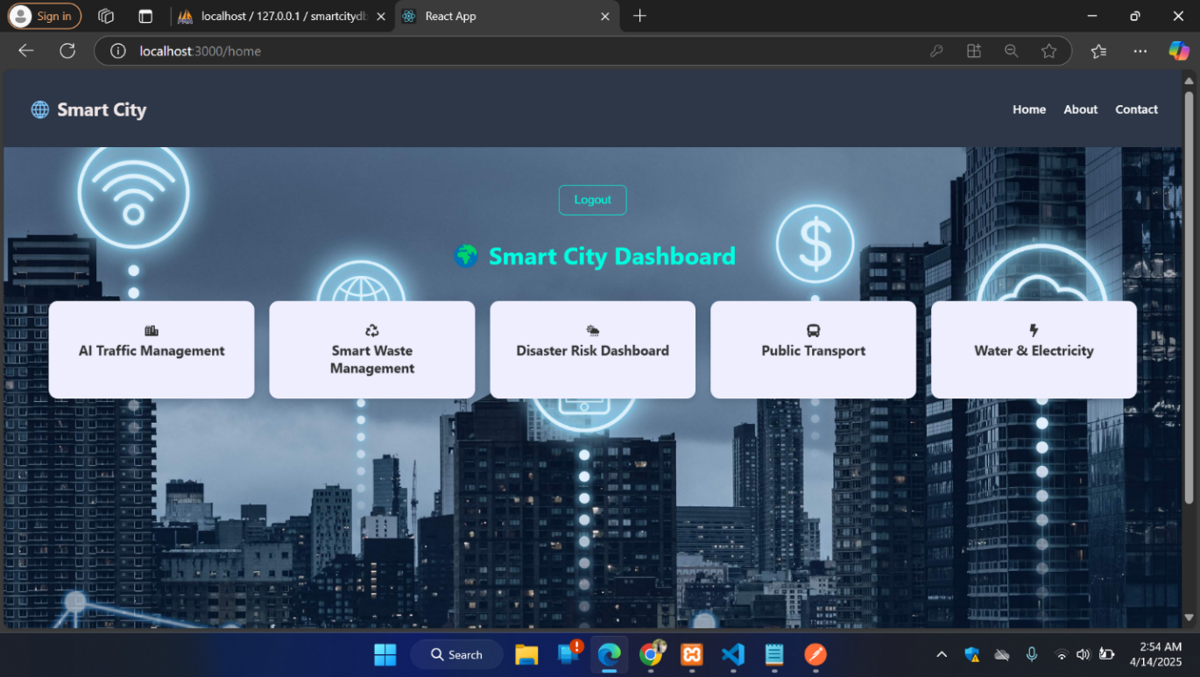

**TRAFFIC PAGE:**

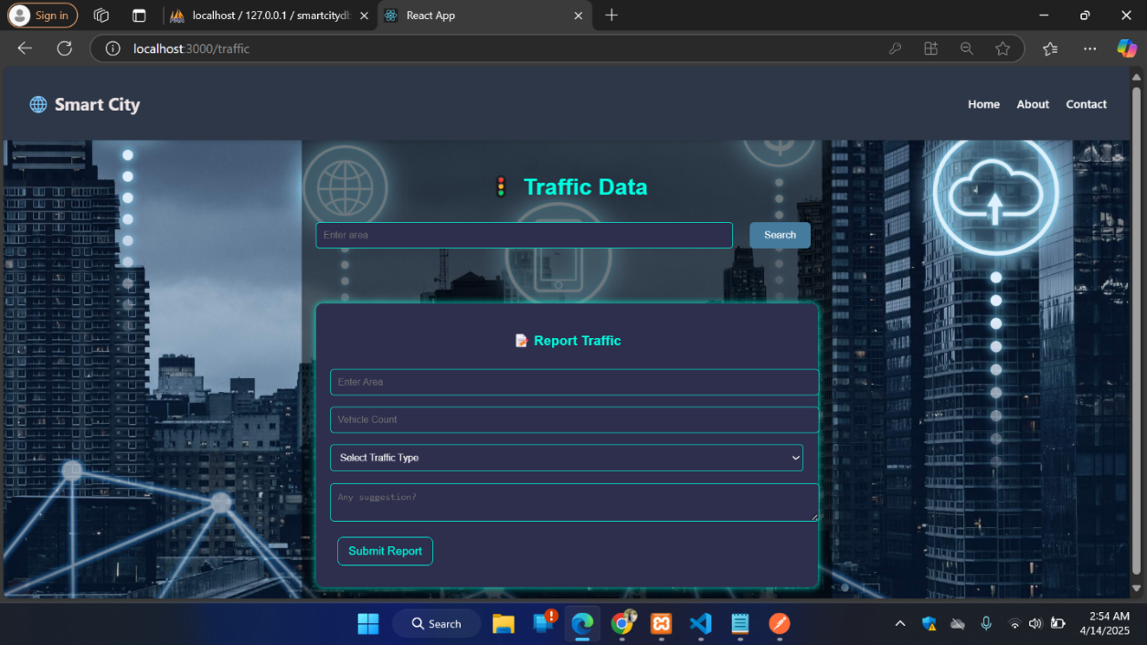

**CHECKING THE TRAFFIC:**

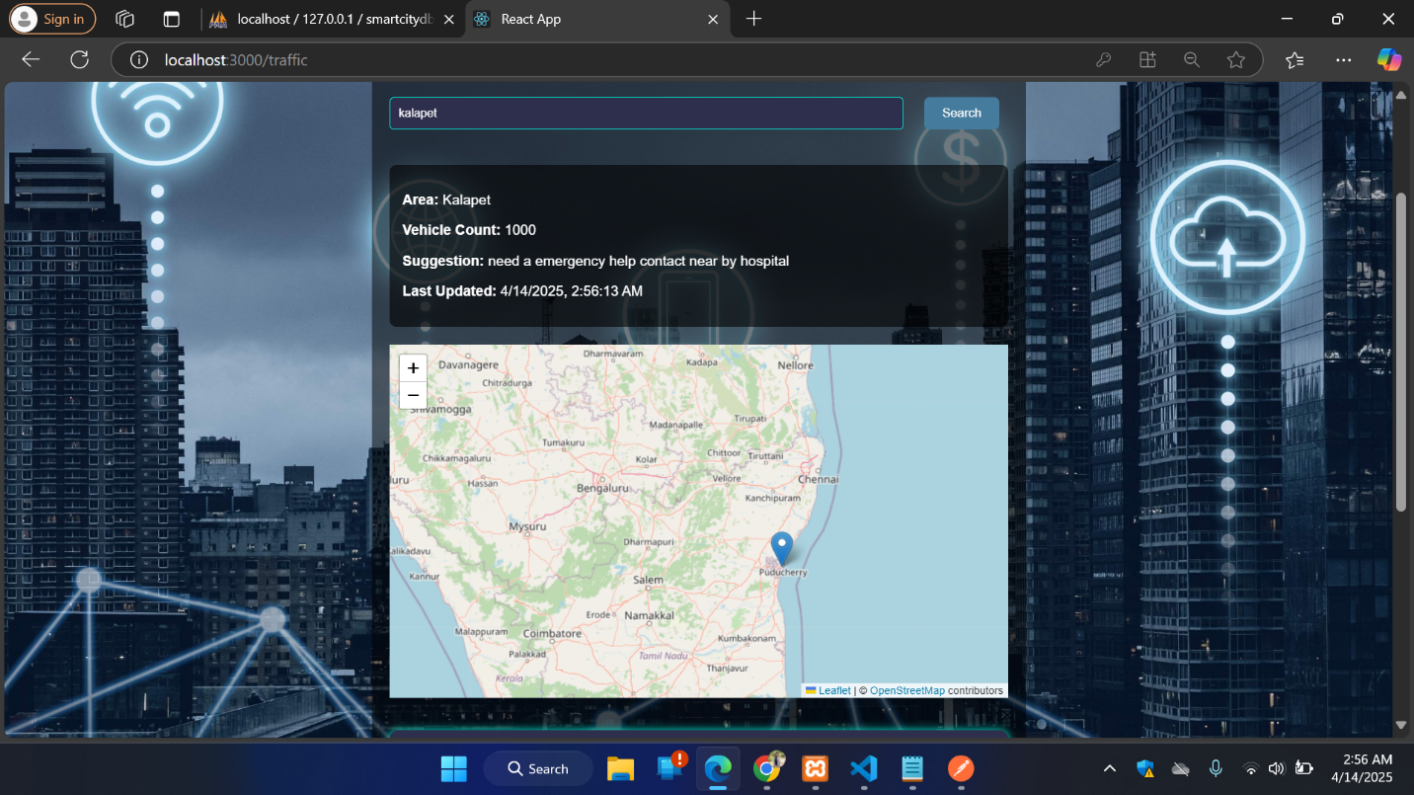

**WASTE MANAGEMENT PAGE:**

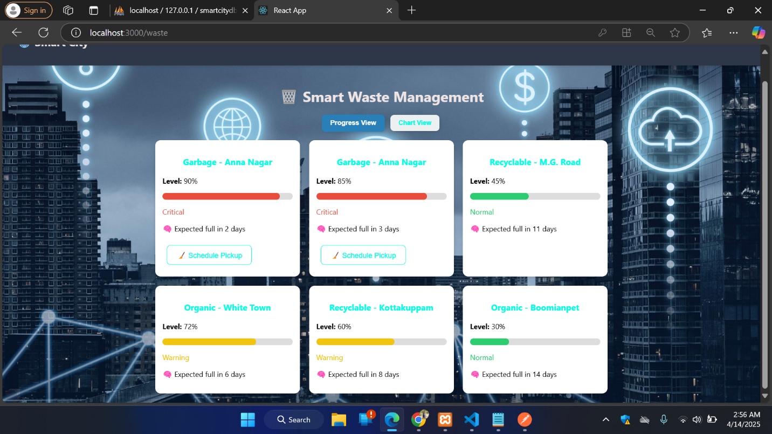

**CHART VIEW (BY TYPES):**

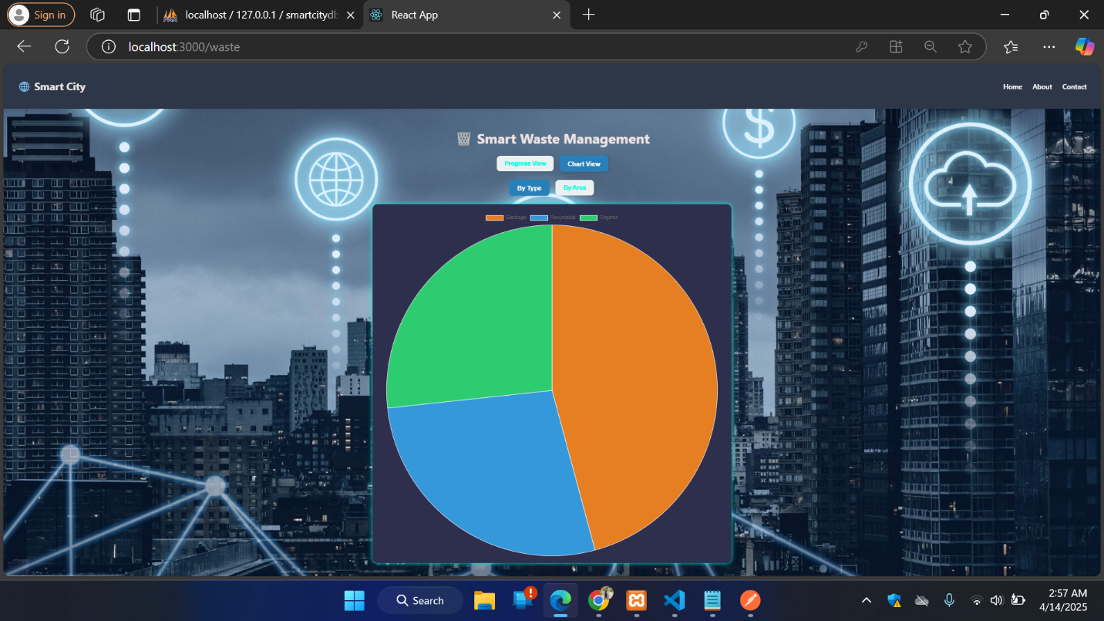

**DISASTER PAGE:**

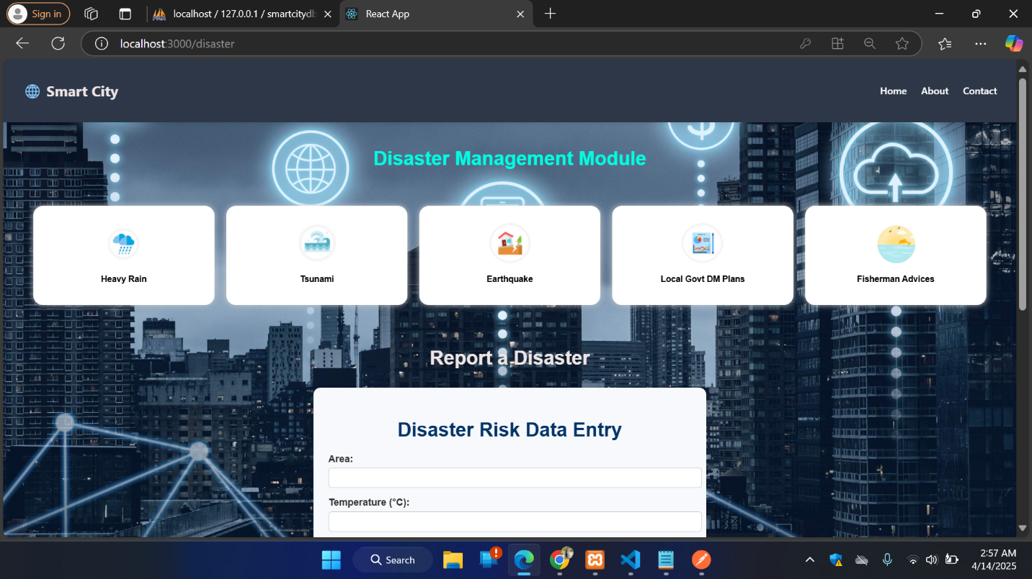

**ADDIND DISASTER DATAS:**

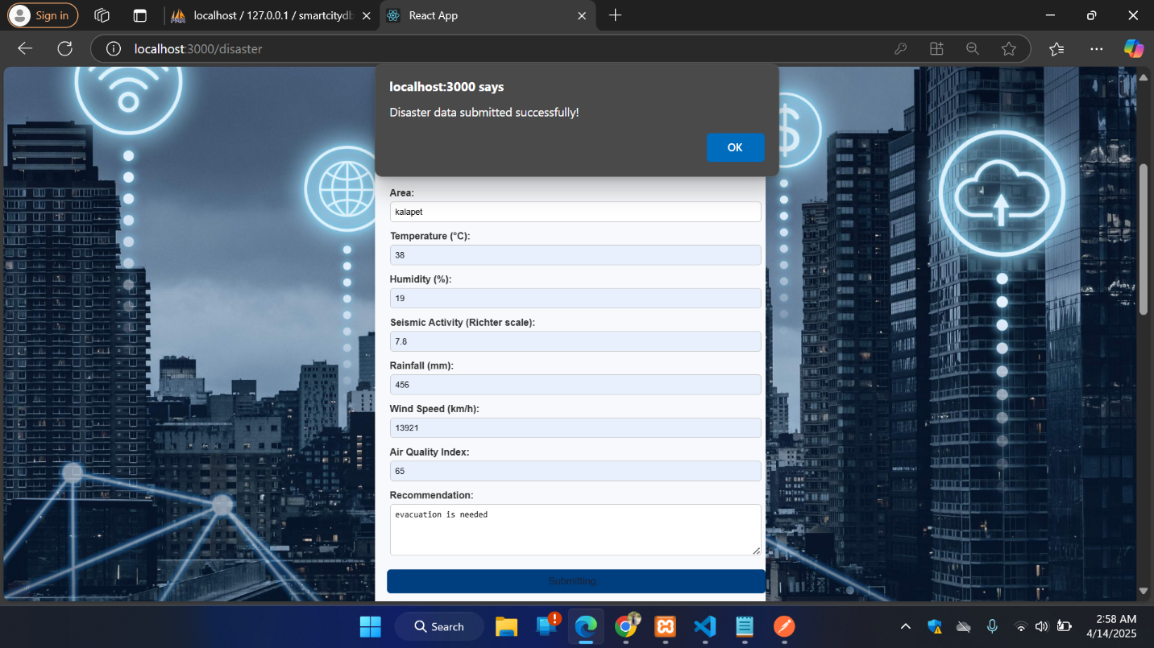

**TRANSPORT PAGE :**

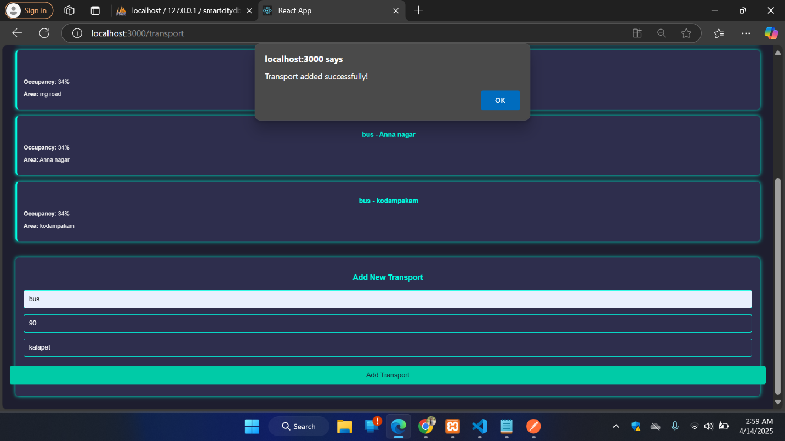

**FILTERING BY MODES AND AREAS:**

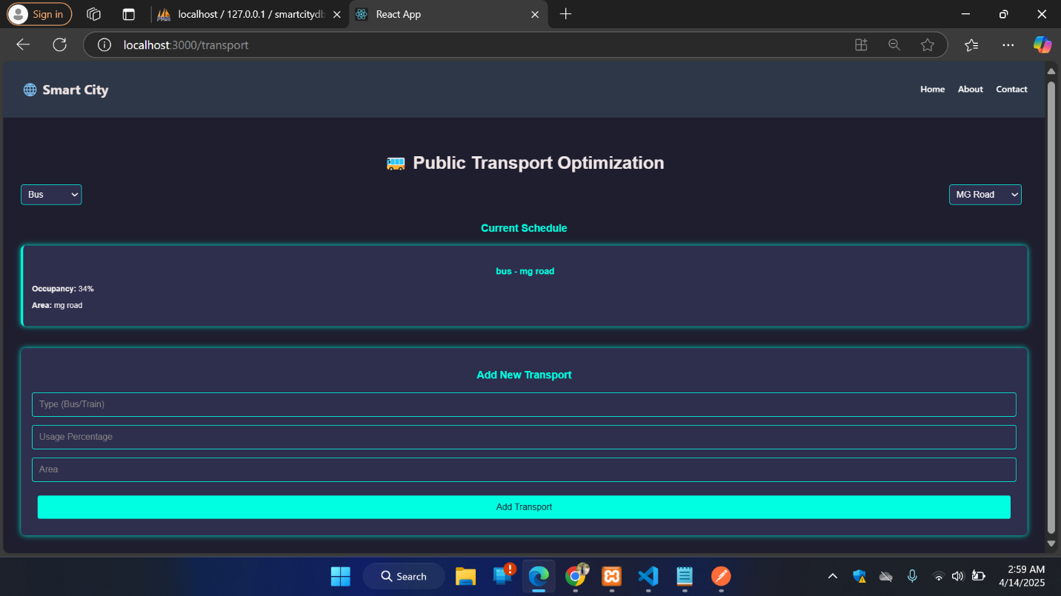

**UTILITY PAGE : ADDING DATAS :**

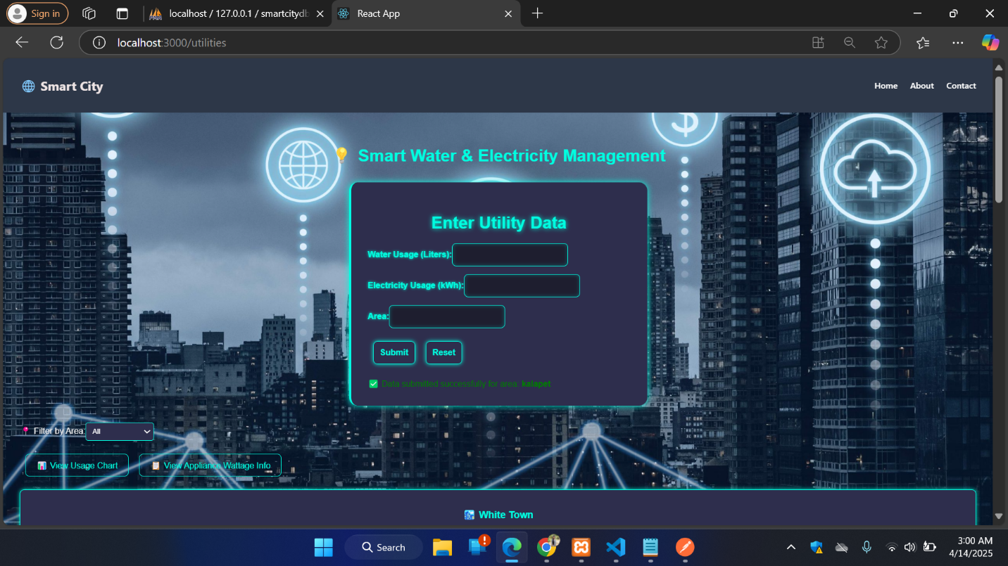

**VIEWING DATAS:**

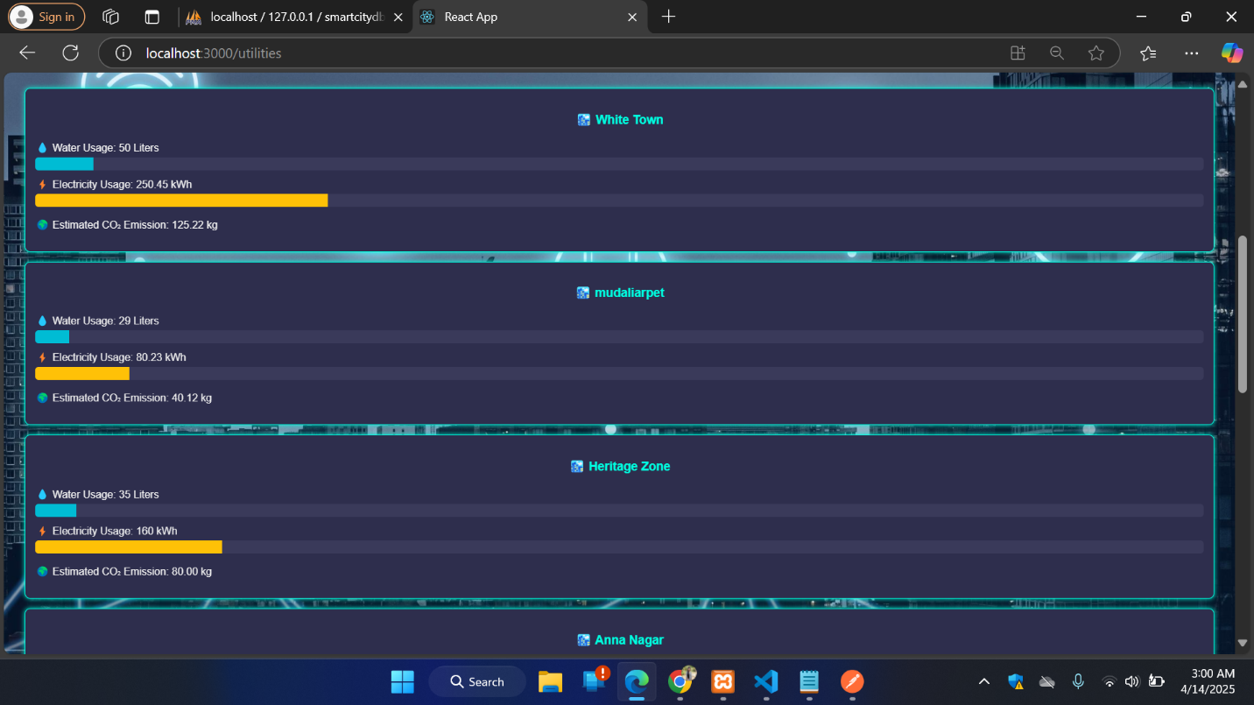

**OVERALL USAGE:**

